Info table

Technical Solution Description

Table of contents
1. Overview 2
2. Frameworks and technologies used 3
3.1 Business logic 4
3.2 UI 4
4 Interaction between application parts. 4
5. Deployment 5

1. Overview
Info table is a web application separate client application for an advertising stand.
The application display the top products and their prices . The data loaded at startup and stored on the client side. Data reloading is carried out in case of receiving a notification from the server about the change of goods and their value.

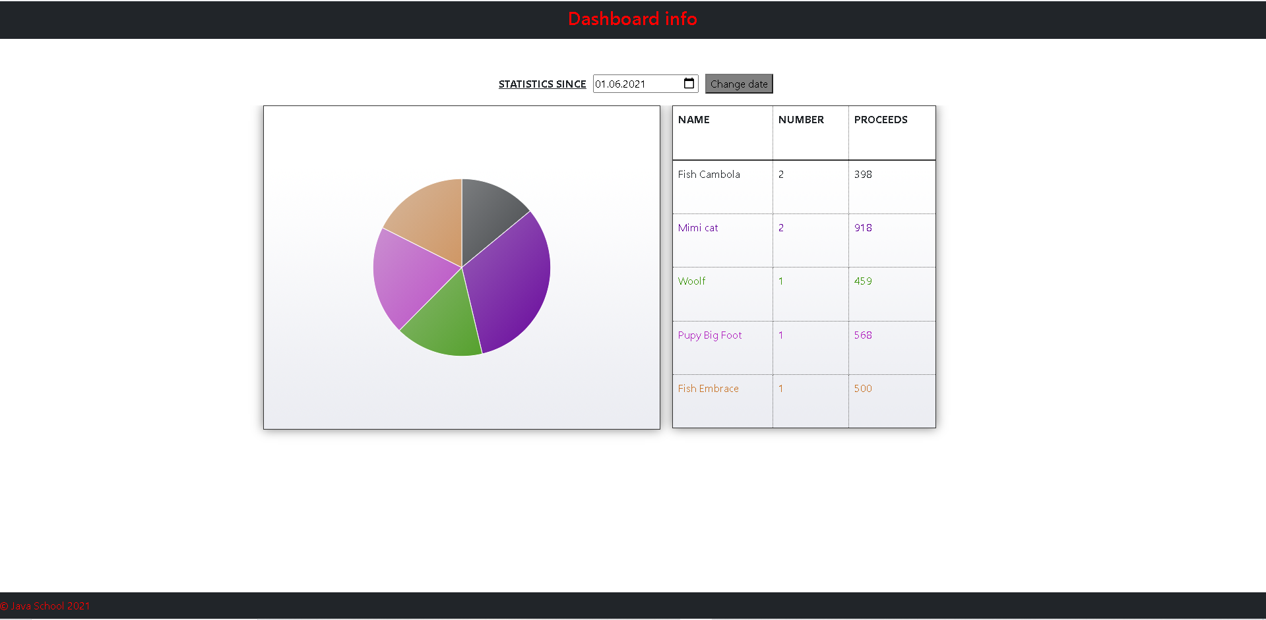
Figure 1. Main page of the application.

2. Frameworks and technologies used
- Java 8
- IntelliJ IDEA Ultimate
- Java EE 8
- EJB 3.2
- JSF 2.1
- PrimeFaces 10.0.0
- Bootstrap 5
- Maven 3.6.3
- JSTL 1.2
- Bootstrap 5
- Maven 3.6.3
- WildFly 23.0.2 Final
- RabbitMQ 5.12.0
- JavaScript

3.1 Business logic
The statistics data is loaded on the start of application (if possible) and then only when a message is received from MQ. Depending on the message, one of two updates is requested – “update” for updating statistic and “goodbye” if connection is lost. Data is stored in application-scoped beans.

3.2 UI
Websockets are used in UI to refresh information on the page without reloading the page itself.

4 Interaction between application parts.
The interaction between the website and a statistics table is shown in Figure 4. When information update occurs, website sends message to MQ server. When the second part receives it, a SOAP request is sent back to the first part and a SOAP response with new information is received.
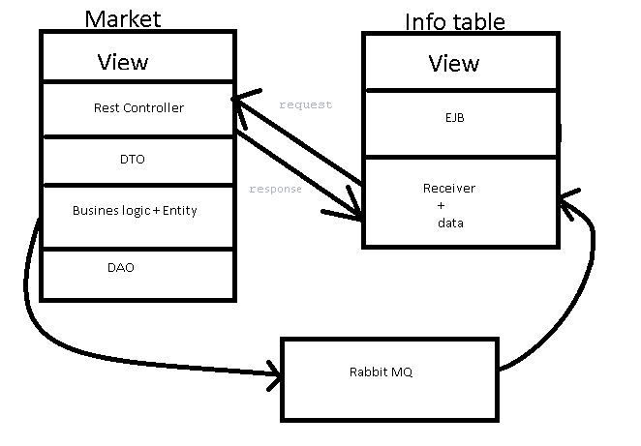
Figure 4. Interaction between the first and the second part of application.

5. Deployment
Building and deployment is done by Maven. Projects is deployed to Tomcat Server with one call of “mvn install” command.

